Examining cross-linguistic permeability in question processing across Dutch-English-speaking bilinguals: A partial replication of Grüter & Hopp (2021)
Theodore Manning and Priya Patel
CUNY Graduate Center

Abstract
The present study is a partial replication of Grüter & Hopp’s 2021 visual world experiment which examined crosslinguistic influence in syntactic processing in German speakers. Our partial replication uses L1 Dutch-English bilinguals residing in The Netherlands or the United Kingdom and Dutch-translated sentences from the 2021 study. Participants’ eye movements were tracked using PCIbex, and theoretically, analysis would be conducted in R. Hypothetical results should yield the same results as Grüter & Hopp (2021), suggesting evidence contra to the Use Hypothesis of cross-linguistic influence in bilingual sentence processing.
Keywords: bilingualism, eye-tracking, visual world paradigm, sentence processing

Examining cross-linguistic permeability in question processing across Dutch-English-speaking bilinguals: A partial replication of Grüter & Hopp (2021)
Grüter & Hopp (2021) examined crosslinguistic influence in syntactic processing. Previous research had supported the idea that a bilingual’s linguistic knowledge is interconnected across their languages at all levels of processing, however most research had been on how an individual’s L1 impacts the processing of their L2. Grüter & Hopp specifically aimed to understand the impact of the L2 on the L1 at the level of sentence processing in late bilinguals. The question being: How do usage, immersion, and order of acquisition impact sentence processing?
The two hypotheses under consideration are adapted from Grüter & Hopp, (2021) and are as follows:
- H1: In sequential bilinguals, the order of acquisition of languages exerts a greater cross-linguistic influence, with a person’s L1 having a significantly greater impact than L2 on sentence processing in L1. This is what Grüter & Hopp (2021) refer to as the Order Hypothesis.
- H2: In sequential bilinguals, use and immersion exert a greater cross-linguistic influence, and a person’s most frequently used language has a more significant impact on sentence processing in a person’s L1. This is what Grüter & Hopp (2021) refer to as the Use Hypothesis.
The present study seeks to understand the cross-linguistic influence of L2 English on L1
Dutch speakers residing in The Netherlands versus the United Kingdom. We utilize a Visual World Paradigm experiment–a replication of Grüter & Hopp’s 2021 study–in which participants’ eye movements are tracked as they listen to ambiguous Dutch constructions describing images, then participants will select an answer on the image for their preferred interpretation of that sentence.

Wh-questions in Dutch
Word order is not always reliable for understanding the underlying syntactic structure of clauses in Dutch due to scrambling (Neeleman, 1994). Typically, subject precedes object, but sometimes the object precedes subject. This syntactic phenomenon occurs commonly in Dutch wh-questions. Furthermore, Dutch noun phrases do not have overt cases, unlike the German we have adapted from Grüter & Hopp’s study, so listeners have even fewer cues to disambiguate meaning from the two underlying structural options present. Ultimately, while both the Subject-Verb-Object interpretation and the Object-Verb-Subject interpretation could be carried by an individual sentence, the Subject-Verb-Object interpretation is typically preferred by Dutch speakers (Schouwenaars et al., 2016). So the question then is: How does cross-linguistic influence from Dutch to English affect the potential interpretation of these ambiguous questions in Dutch, when their translations are unambiguous in English?
Method

Design
The goal of this experiment is to understand the impact of immersion and use on syntactic processing, with the Order and Use Hypotheses of Grüter & Hopp (2021) in mind.
Specifically, we aim to understand how, if at all, country of residence as a proxy for immersion impacts L1 Dutch, L2 English speakers’ processing of ambiguous Dutch whquestions. The experiment will look at the syntactic preferences of L1 Dutch speakers residing in the Netherlands and residing in the United Kingdom. Borrowing Grüter & Hopp’s (2021) terms, these will be referred to as the ”Dutch homeland” group and the ”Dutch expat” group respectively.
We will test the impact of cross-linguistic influence on the processing of wh-questions through a visual world eye-tracking experiment, where participants will be presented with ambiguous wh- questions and asked to answer with a single selection that reflects either a subject- or object- interpretation of the question. Eye-tracking data will be analyzed for proportion of looks to subject or object, giving more insight into participants’ processing than analyzing final selections alone. Participants will be given four ambiguous present tense trial questions, four ambiguous perfect tense trial questions interspersed with present and perfect tense filler questions which are unambiguous. Because the perfect tense trials necessarily always follow a present tense trial with the same image and verb, as in the original Grüter & Hopp (2021) experiment, it would be difficult analyze data in such as way as to make any claims about the combined participant groups’ overall preferences for subject- and objectinterpretations across tenses. Therefore, this experiment is designed in such as way as to understand the relative subject- and object- preferences between the Dutch expat and Dutch homeland groups.
If English use and immersion does indeed exert a strong influence on our participants’ Dutch sentence processing, i.e. if the data favor the Use Hypothesis, then we expect to see a significant difference between the two groups, with Dutch expats more often choosing subjectreadings for present tense questions (What <verbs> the <animal>), and object- readings for the perfect tense questions (What had the <animal> <verbed>). If the data instead favor the Order Hypothesis, we expect to see no significant difference between groups’ interpretations.

Participants
Participants for the pilot study were recruited via Prolific and compensated $5 USD for their participation. Participants were recruited from two categories: L1 Dutch, L2 English speakers residing in The Netherlands; and L1 Dutch, L2 English speakers residing in the United Kingdom. Originally, we wanted to recruit individuals residing in the United States, however there were not enough L1 Dutch speakers in the United States registered on Prolific to run the experiment.

Participant View
Due to Prolific’s need to record participants IDs, a simple Google Form was created. A
Qualtrics form would have been preferred, but was unfortunately inaccessible to us. The Google Form contained full instructions for participants; a line to fill in their Prolific ID; a link to the experiment; and a reminder to submit the form.
After clicking the experiment link, participants were directed to PCIbex, where they read an abridged version of the instructions, then continued to do their first eye calibration.
For each stimulus set, participants heard a Dutch sentence with an accompanying image as their eye movements were tracked, and they were instructed to click the ‘answer’ (image) to the question–whichever answer they favored indicating which translation was preferred.
Eye movements were tracked to indicate what translation the participants were considering, in addition to which answer they considered prior to their selection; as well as how long were processing these choices.

Materials
For the pilot study, images for two verbs, push, and chase, were selected from the original Grüter & Hopp (2021) materials. Each verb was accompanied by two distinct visual scenes, which were chosen for visual simplicity, minimizing overlap between animals to facilitate encoding of rectangular areas of interest in the eye-tracking software. For each visual scene, two different styles of images represented the present and perfect tense, as in Grüter & Hopp (2021). Present tense questions, both trials and fillers, were accompanied by a full color image, while perfect tense questions were accompanied by a bleached image consisting of a simple faded outline (Fig 1). Participants were always shown an introduction to a scene accompanied by a present tense, full color image, followed by a present tense trial or filler, followed by a perfect tense trial of filler.
The sentences and questions used in this experiment were adapted from Grüter & Hopp (2021). They were first translated from German to English (with each possible translation being kept), then translated from English to Dutch by a native Dutch speaker. The audio for the sentences were recorded by a female native Dutch speaker residing in the Netherlands, and were edited in Praat (Boersma & Weenink, 2009) to remove silence and ’human sounds’ like sniffling. Introductory sentences named all of the animals in the scene and stated that the animals were performing a verb on each other as depicted in(1). Filler questions were unambiguous, asking either about the characteristics of an animal, e.g. Welk dier had zijn tanden laten zien? (Which animal had showed its teeth?), or asking about animals in relation to one another in an unambiguous way, e.g. Welk dier zit er achter de kip? (Which animal is behind the chicken?). All visual and audio stimuli can be found at https://osf.io/watzj/.
(1) Hier is een eend, een kat, een zebra en een koe.
De dieren duwen elkaar, en een dier duwt ander andere.
’Here is a duck, a cat, a zebra, and a cow.
The animals push each other, and one animal pushes another.’
To set up the pilot experiment, we used PCIbex (Zehr & Schwarz, 2023), a JavaScript-based experiment platform that allows us to run webcam-enabled experiments remotely via a shared link. Areas of interest for subject, object, noun stated in the question, and competitor were drawn onto the visual scenes (Fig 3). Gaze data can then be logged for each area of interest and then downloaded and analyzed. A more sophisticated experimental platform, such as SMI BeGaze would have allowed for more complex areas of interest to be encoded (Grüter & Hopp, 2021).
The eye-tracking experiment can be accessed via https://farm.pcibex.net/p/LyMxhS/.

Procedure
After reading the instructions and undergoing calibration for the web-based eye tracking platform in English, participants would begin the experiment with three practice scenes with Dutch narration, followed by the first visual scene for the first verb. For the initial eye-tracking calibration, the threshold was set to above 50%, however for subsequent calibrations between trails the threshold was set to above 30%. For each visual scene, participants would begin by hearing an introductory Dutch sentence outlining the animals in the scene and the verb being performed, as depicted in (1). This introductory sentence would be accompanied by a full color version of the scene (Fig 1). Following the introductory sentence, participants would hear a present tense filler question, followed by a present ambiguous tense trial question, both with full color images. Participants would click the animal that best answers the question. After the present tense trial and filler, participants would hear a perfect tense filler, followed by a perfect tense trial, both accompanied by a bleached version of the scene (Fig. 2).

Data Analysis
Once reliable data are obtained, we would conduct an analogous analysis to Grüter &
Hopp (2021), and, as in that experiment would expect to see evidence in favor of the Order Hypothesis contra the Use Hypothesis. Namely, we would expect that there is no significant impact of country of residence on subject selections or gaze data, and that there is no significant interaction between country of residence and tense on the same. More specifically, our analysis would consist of using logit mixed effects models (Kuznetsova et al., 2017) to estimate the likelihood of a subject selection as a function of country of residence and the interaction between country of residence and tense as fixed effects. For the gaze data, we would do something similar, using linear mixed effects models to analyze proportions of looks to the subject as a function of country of residence and the interactions between country of residence and tense. For completeness, we would repeat this analysis for looks and selections of the object area of interest. For this pilot, we coded four different areas of interest in order to ensure that we could capture the full extent of selection and gaze data. This should not impact the analysis, except insofar as the areas of interest are less precise than a more sophisticated eye-tracking setup would allow. Proportions of gaze data and selections of the subject or object would not be impacted.

Future Directions
Having run the pilot, we hope to conduct an in-person version of this experiment with the Tobii Pro Eye-Tracker, pending time and the ability to recruit L1 Dutch speakers residing in the United States physically. This in-person experiment does have the limitation of completing the part of the experiment that would take place in The Netherlands, however that can be remedied with colleagues and travel. Since Grüter & Hopp (2021) saw that order of acquisition and tense significantly impacted participants’ subject- and object- interpretations, we would like to find L1 English, L2 Dutch speakers residing in The Netherlands and in the United States to recreate the full study.

Acknowledgements
We would like to thank Dr. Irina Sekerina for her guidance and instruction on this project, as well as Isa van der Steen for serving as our Dutch consultant and providing us with experimental audio.

References
Boersma, P., & Weenink, D. (2009). Praat: Doing phonetics by computer (version 5.1.13).
http://www.praat.org
Grüter, T., & Hopp, H. (2021). How permeable are native and non-native syntactic processing to crosslinguistic influence? Journal of Memory and Language, 121, 104281.
https://doi.org/10.1016/j.jml.2021.104281
Kuznetsova, A., Brockhoff, P. B., & Christensen, R. H. B. (2017). Lmertest package: Tests in linear mixed effects models. Journal of Statistical Software, 82(13), 1–26.
https://doi.org/10.18637/jss.v082.i13
Neeleman, A. (1994). Scrambling as a d-structure phenomenon. Studies on scrambling: Movement and non-movement approaches to free word-order phenomena, 387, 430.
Schouwenaars, A., Ruigendijk, E., & Hendriks, P. (2016). Wh-questions in Dutch and German: An optimality theory approach. [Unpublished manuscript].
Zehr, J., & Schwarz, F. (2023, January). Penncontroller for internet based experiments (IBEX).
https://doi.org/10.17605/OSF.IO/MD832

Figure 1
Sample present tense image of the verb ”push,” taken from original Grüter & Hopp (2021) materials.
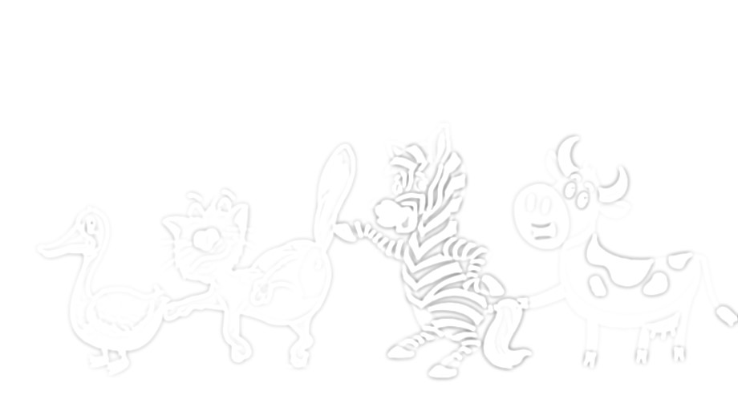

Figure 2
Sample bleached perfect tense image of the verb ”push,” taken from original Grüter & Hopp (2021) materials.
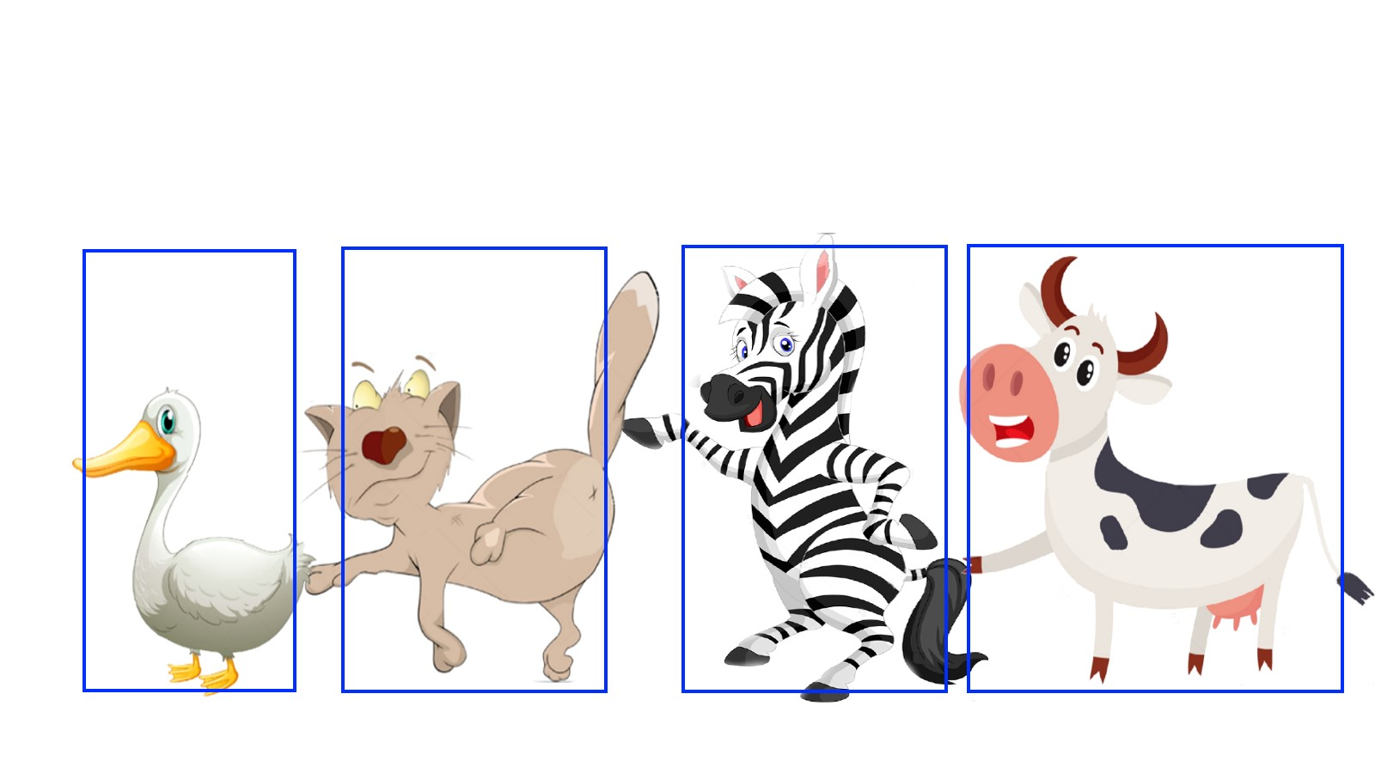

Figure 3
Example of regions of interest that can be drawn in PCIbex. Similar regions were drawn in all images included in the pilot experiment implementation.

